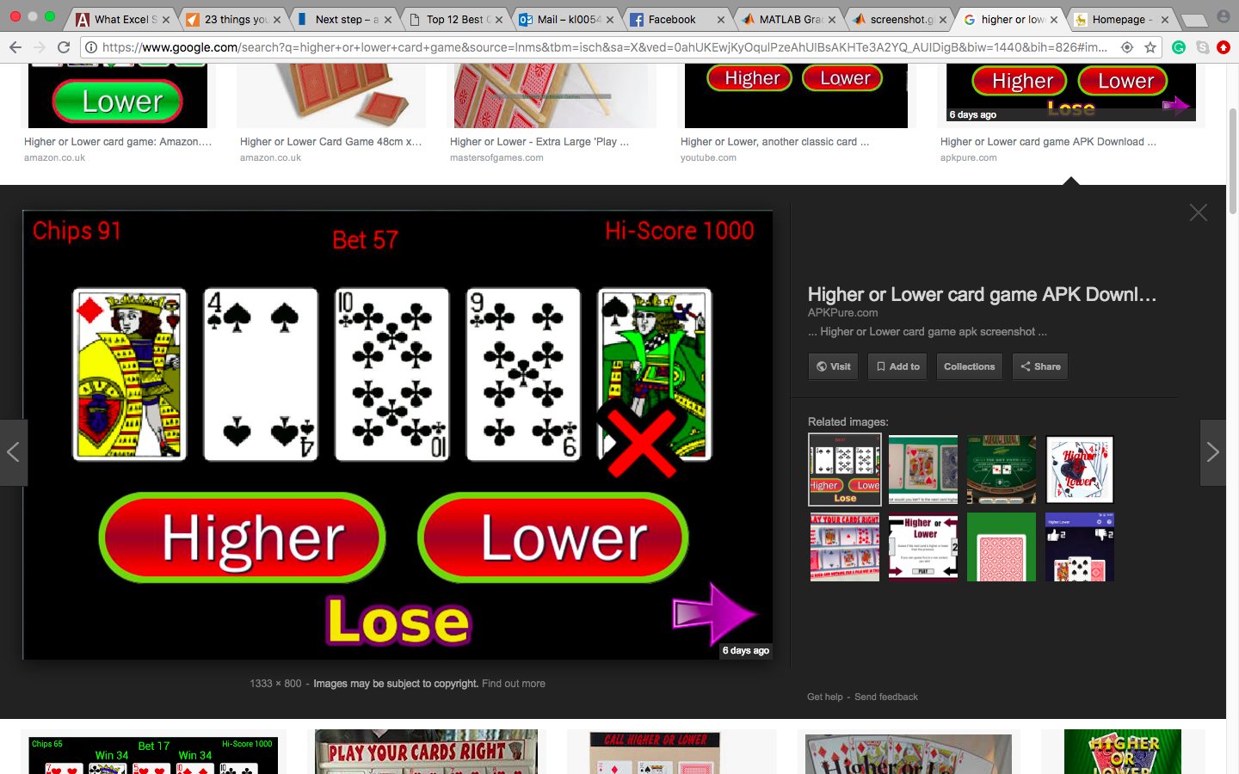

-this is too basic if it’s just a one-time-game

-five card would face down first , START button

- after clicking start, first card reveal, and two options appear, HIGHER or LOWER

-one would be selected, and the second card would reveal,

After 5 cards have revealed, two options would be appeared, ( CONTINUE, CASH OUT)

If the player chose ‘CONTINUE’, a new game starts, but the score is carried on to the next round

5 round max?

(have to learn how to code the order of the card)

Versions  
1) basic – same 5 cards everytime

2)medium- random cards (13) queen jack king have different values to avoid same card value

3)hard- include suits

Score:

Get one right>>> +100

Get two right >>> +200

Get three right >>> +300

Get four right >>> +400 (in a roll)

Get it wrong >> lose everything

Function we need to learn:

Make images into buttons

How to change the image (flipping )

Upload images

Place the images on the right place (coordination)

How to place order of the images

To tell whether the player win this round

How to add on and deduct the score

The transactions from the start to the main game and to the next round.